**K L UNIVERSITY – {HYD}**

**FRESHER’s ENGINEERING DEPARTMENT**

**A Project Based Lab Report**

**On**

**: SPORTS REGISTRATIONS :**

**SUBMITTED BY:**

I.D NUMBER NAME

2010030236 Mohammed Adnan.

.

**UNDER THE ESTEEMED GUIDANCE OF**

**Ms.Sai Sudha Gadde ma’am**

**Cse-HOD**



**KL UNIVERSITY**

**DEPARTMENT OF BASIC ENGINEERING SCIENCES**



**CERTIFICATE**

This is to certify that the project based laboratory report entitled “**SPORTS REGISTRATIONS**” submitted by Mr/Ms**. MOHAMMED ADNAN** bearing Regd. No. 2010030236 to the **Department of Basic Engineering Sciences, KL University** in partial fulfillment of the requirements for the completion of a project in “Object Oriented Programming-19CS1203”course in I B Tech II Semester, is a bonafide record of the work carried out by him/her under my supervision during the academic year 2020-21.

PROJECT SUPERVISOR HEAD OF THE DEPARTMENT

Ms.Sai Sudha Gadde. Dr. G. REKHA

**ACKNOWLEDGEMENTS**

It is great pleasure for me to express my gratitude to our honorable President **Sri. Koneru Satyanarayana**, for giving the opportunity and platform with facilities in accomplishing the project based laboratory report.

I express the sincere gratitude to our Principal **Dr. L. Koteswara Rao** for his administration towards our academic growth.

I express sincere gratitude to our Coordinator and HOD-BES **Dr. G. Rekha** for her leadership and constant motivation provided in successful completion of our academic semester. I record it as my privilege to deeply thank for providing us the efficient faculty and facilities to make our ideas into reality.

I express my sincere thanks to our project supervisor Ms. Sai Sudha Gadde mam for his/her novel association of ideas, encouragement, appreciation and intellectual zeal which motivated us to venture this project successfully.

Finally, it is pleased to acknowledge the indebtedness to all those who devoted themselves directly or indirectly to make this project report success.

Name: **Enosh Friesen Raj.Irigi**

Regd . No: 2010030255.

2010030236

**Md.Adnan.**

2010030256 **HanumanMohan.**

**ABSTRACT**

* THE OBJECTIVE OF THIS PROJECT IS TO PROVIDE MANAGEMENT FACILITY TO SPORTS FIELD.HERE ARE SOME SERVICES ALLOTED TO USERS
* It allows user multiple sports options.
* User can find option to enroll for singles and doubles (if available in sport).
* User friendly options .
* Modify enrollments easily.
* And can register for his/her willing game.
* Can register successfully.
* This is the process of registration for the sports.

**INDEX**

|  |  |  |
| --- | --- | --- |
| **S.NO** | **TITLE** | **PAGE NO** |
| 1 | Introduction | <pageno> |
| 2 | Aim of the Project | <pageno> |
| 2.1 | Advantages & Disadvantages | <pageno> |
| 2.2 | Future Implementation | <pageno> |
| 3 | Software & Hardware Details | <pageno> |
| 4 | Class Diagram | <pageno> |
| 5 | Implementation | <pageno> |
| 6 | Outputs/ScreenShots | <pageno> |
|  |  |  |
| 7 | Conclusion | <pageno> |

**INTRODUCTION**

what is GUI ?????

The **graphical user interface**  is a form of [user interface](https://en.wikipedia.org/wiki/User_interface) that allows [users](https://en.wikipedia.org/wiki/User_(computing)) to [interact with electronic devices](https://en.wikipedia.org/wiki/Human%E2%80%93computer_interaction) through graphical [icons](https://en.wikipedia.org/wiki/Icon_(computing)) and audio indicator such as primary notation, instead of [text-based user interfaces](https://en.wikipedia.org/wiki/Text-based_user_interface), typed command labels or text navigation. GUIs were introduced in reaction to the perceived steep [learningcurve](https://en.wikipedia.org/wiki/Learning_curve) of [command-line interfaces](https://en.wikipedia.org/wiki/Command-line_interface)  which require commands to be typed on a [computer keyboard](https://en.wikipedia.org/wiki/Computer_keyboard).

IMPORTANCE OF GUI :

=========================

GUI is an interface that allows users to interact with different electronic devices using icons and other visual indicators. The graphical user interfaces were created because command line interfaces were quite complicated and it was difficult to learn all the commands in it.

In today’s times, graphical user interfaces are used in many devices such as mobiles, MP3 players, gaming devices, smartphones etc.

**AIM**

**Advantages :**

**You'll be operating more efficiently and parents will be happier because they can sign their kids up 24/7, whenever is convenient.**

* Easy **Registration** Management. Easy **Online Registration**. ...
* Collect & Manage Payments **Online**. Secure Payment Collection. ...
* LESS LEAGUE ADMINISTRATION. Reduce Paperwork. ...
* We are Family.

**Disadvantages :**

* Lack of accreditation and low quality. Before you enroll in any **online** course, check that the program is accredited and verify this information with the accrediting agency. ...
* Little or no face-to-face interaction. ...
* More work. ...
* Intense requirement for self-discipline. ...
* Even more intense requirement for self-direction.

**SYSTEM REQUIREMENTS**

* **SOFTWARE REQUIREMENTS:**

The major software requirements of the project are as follows:

Language : JAVA

Operating system**:** Windows XP or later.

Tools: Eclipse IDE

* **HARDWARE REQUIREMENTS:**

The hardware requirements that map towards the software are as follows:

RAM : 8gb

Processor : 11th gen intel.

**CLASS DIAGRAM**

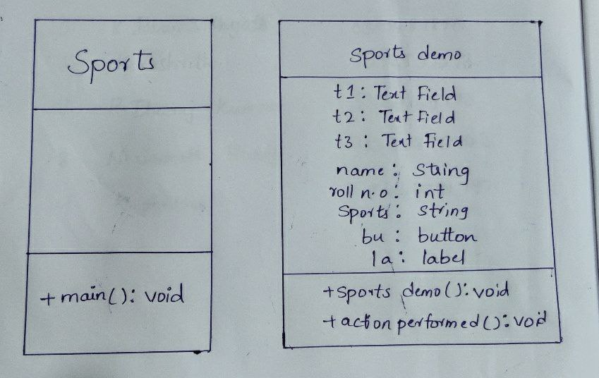

**IMPLEMENTATION**

OUTPUTS

**Sample INPUT**

**Name: enosh**

**ID n.o : 2010030255**

**Sports : tabletennis**

**Mode of play: singles**

**Sample OUTPUT**

**Name: enosh**

**ID n.o : 2010030255**

**Sports : tabletennis**

**Team n.o - 2**

**Mode of play: singles**

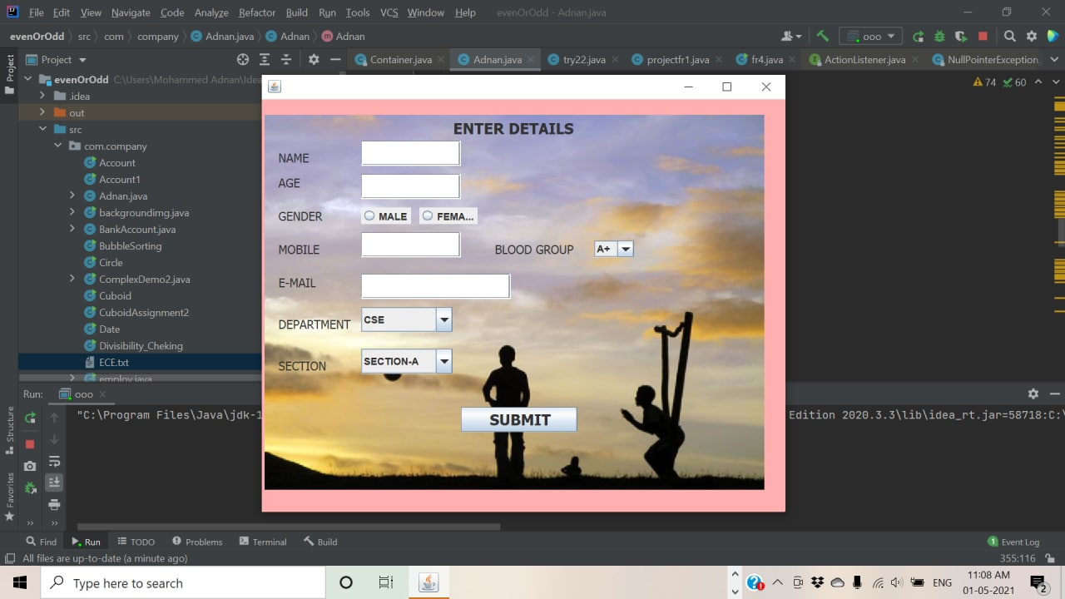

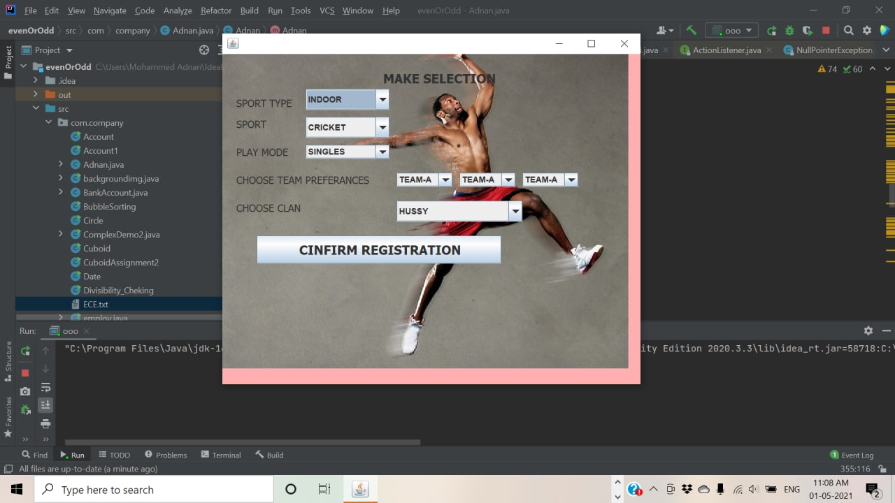

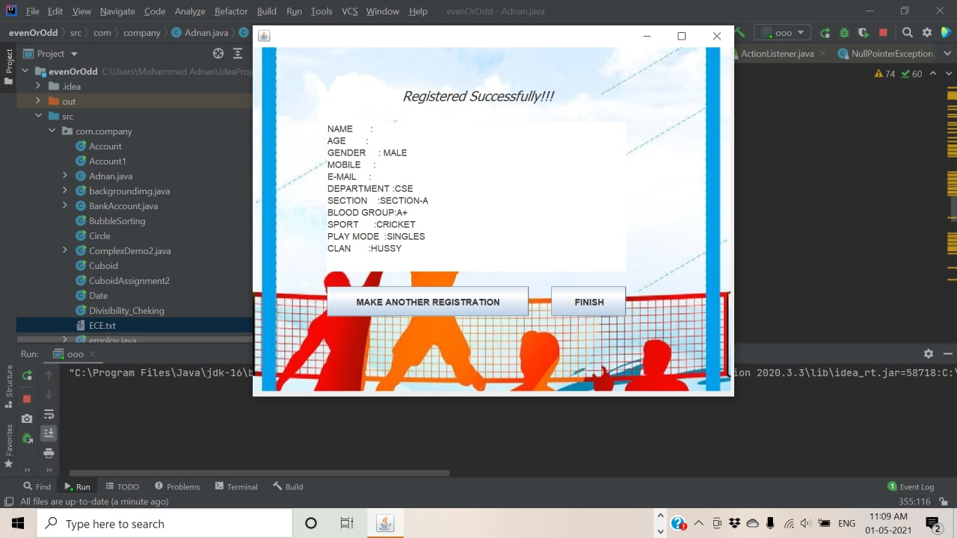

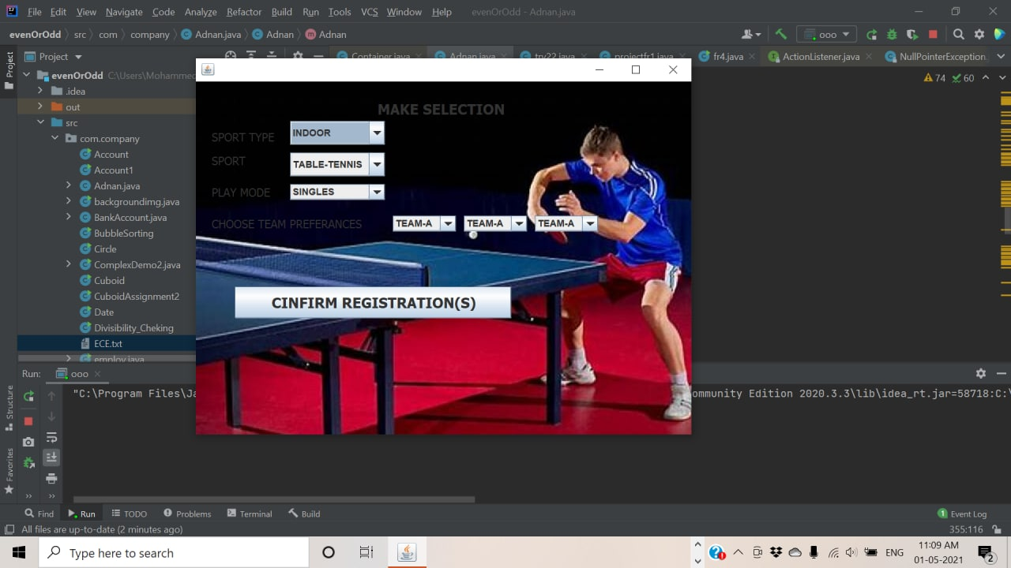

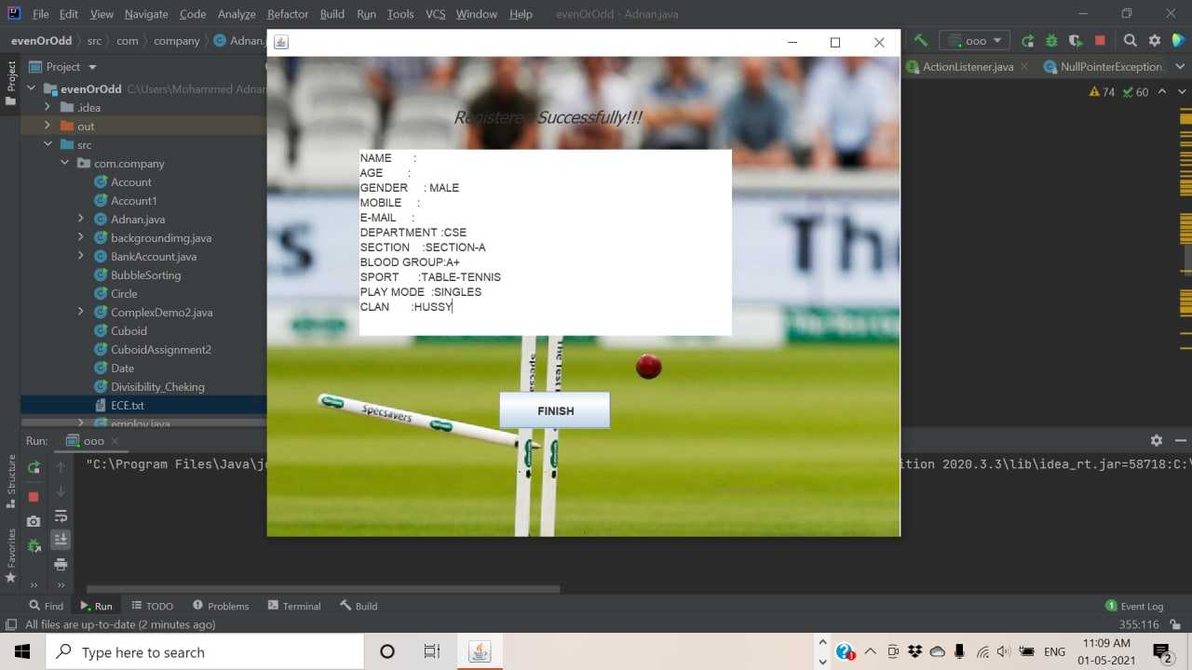

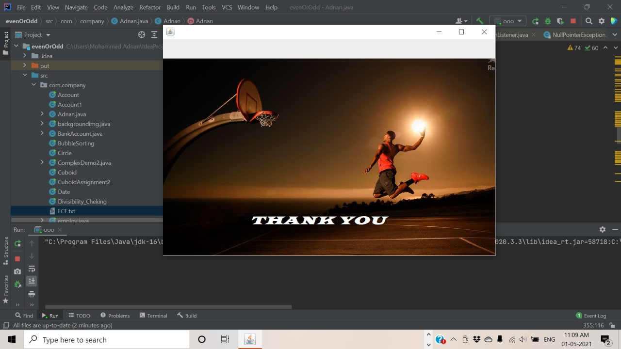

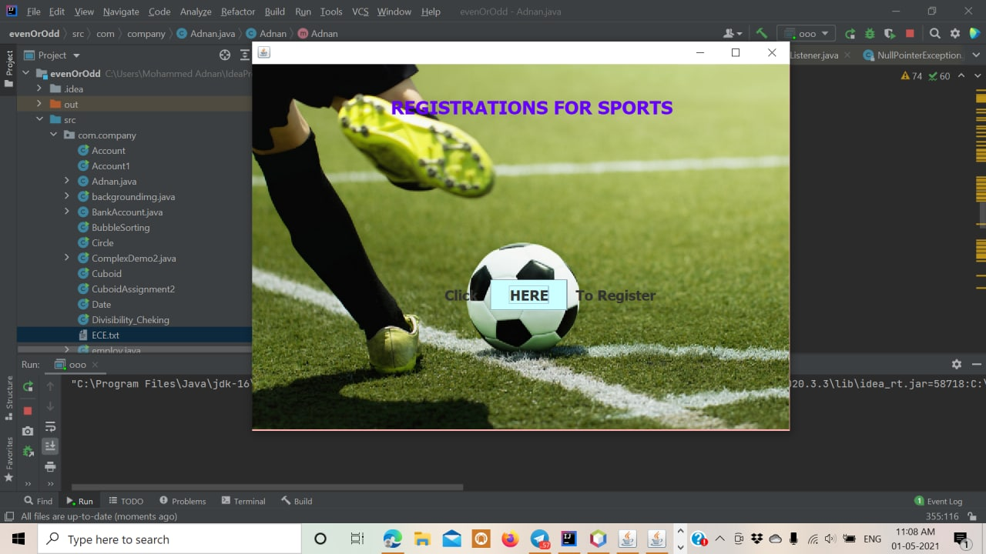

**CONCLUSION**

**& Future Work.**